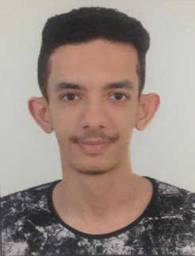

**Ali Jamal Ali Salman Khalaf**

**House: 1900 Road: 5749 Block: 457 BuQuwah**

**Mobile: 66763745**

**Email: Alijamalali95@gmail.com**

**Personal Details**

**Nationality:**  Bahraini

**Date of Birth:** 24. May.1995

**Place of Birth:** Manama

**Age:** 24

**Marital Status:** Single

**CPR Number:** 950508063

**Educational Qualification**

Secondary Certificate in Commercial Sciences - (Shiek Abdulaziz Al Khalifa Secondary Boys School) 2011-2013

Bachelor degree in Management\Marketing Major – (Ahlia University) 2013-2018

* Arabic (Native)

**Language**

* English (Very Good)

**Personal Skills**

* Communication skills.
* Analytical and problem-solving skills
* Time management skills
* Ability to handle pressure
* Hard Worker
* Good leadership skills
* Good Organizer skills

**Computer Skills**

* Professional in Windows xp & Microsoft Office (Word, Excel, Power point ….).

**Hobbies**

* Exploring in the internet about anything I want about reading magazines & some sports activates & reading and sending Emails.
* Reading, especially novels and historic stories.
* Sports, Basketball and football.
* Amateur Photographer and Video Recorder.

**Certifications & Participations**

* **10th Annicersary Young entrepreneurs competition 2018 & annual appreciation ceremony Of INJAZ Bahrain ( Certificate of Achievement)**
* **Breast Cancer awareness month – Oct 2017 with TogetherSafe team from Ahlia University in BahrainBay.**
* **GIS Day ( Certificate of participation )**
* **Visiting the weekly session of the house of representatives on the sideline of the organization of Bahrain Parliamentary training centre " Citizenship and parliamentary culture" with ahlia university . ( Certificate of participation )**